1. **Mock-Up**

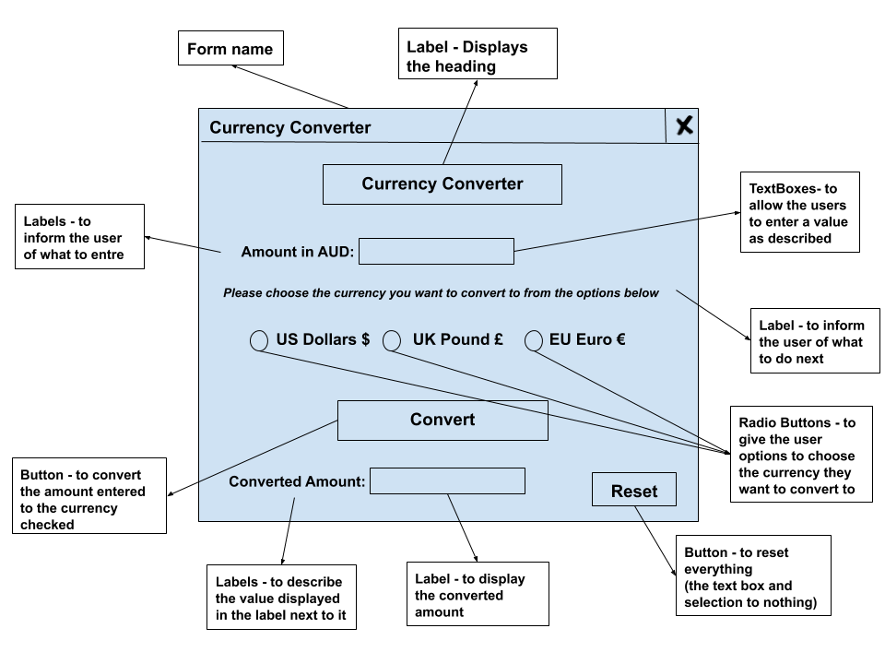

1. **Object Description:**

|  |  |  |  |  |
| --- | --- | --- | --- | --- |
| **Name** | **Type** | **Purpose** | **Attached procedure** | **Formatting information** |
| HeadLabel | Label | To display the heading of the program | - | Microsoft Sans Serif  Black - Bold  16 |
| AUDLabel | Label | To inform the user of what to entre | - | Microsoft Sans Serif  Black - Bold  10 |
| AUDTxtBox | Text box | To allow the users to enter the AUD amount | Convert() | Microsoft Sans Serif  Black - Bold  11 |
| InstructionLabel | Label | To inform the user of what to do next – i.e. choose an option | - | Microsoft Sans Serif  Black – Bold - Italic  9 |
| USRadioBtn | Radio Button | To give the user options to choose the currency they want to convert to (US) | Convert() | Microsoft Sans Serif  Black - Bold  11 |
| UKRadioBtn | Radio Button | To give the user options to choose the currency they want to convert to (UK) | Convert() | Microsoft Sans Serif  Black - Bold  11 |
| EURadioBtn | Radio Button | To give the user options to choose the currency they want to convert to (EU) | Convert() | Microsoft Sans Serif  Black - Bold  11 |
| ConvertBtn | Button | To convert the amount entered to the currency checked - **To run the Convert() method** | Convert() | Microsoft Sans Serif  Black - Bold  11 |
| ConvertHeadLabel | Label | To describe the value displayed in the label next to it | - | Microsoft Sans Serif  Black - Bold  10 |
| ConvertDisplayLabel | Label | to display the converted amount | Convert() | Microsoft Sans Serif  Black - Bold  10 |
| ResetBtn | Button | to reset everything  (the text box and selection to nothing) | Reset() | Microsoft Sans Serif  Black - Bold  11 |

**3. Data Dictionary**

|  |  |  |  |
| --- | --- | --- | --- |
| **Name** | **Purpose** | **Data Type** | **Size** |
| vAUDAmount | To store the amount of money the user enters | Double | 10 |
| vChoice | To store the user’s choice, if the user chooses US - UK or EU | String | 4 |
| vConverted | To store the converted value of the amount of money | Double | 10 |

**4. Pseudocode**

Create two local variables vConverted and vChoice

**ConvertBtn_Click**

**Begin**

Convert()

**End**

Convert()

**Begin**

**Get** AUAmount from AUDTxtBox

**If** USRadioBtn is checked **Then**

vChoice <- “US”

**ElseIf** UKRadioBtn is checked **Then**

vChoice <- “UK”

**ElseIf** EURadioBtn is checked **Then**

vChoice <- “EU”

**Else**

**Display** Please choose a currency to convert to

**EndIf**

**If** vChoice = “US” **Then**

vConverted <- AUAmount * 0.70

**Display** vConverted in the ConvertDisplayLabel

including the $ sign infront of the number

**ElseIf** vChoice = “UK” **Then**

vConverted <- AUAmount * 0.54

**Display** vConverted in the ConvertDisplayLabel

including the £ Sign infront of the number

**ElseIf** vChoice = “EU” **Then**

vConverted <- AUAmount * 0.63

**Display** vConverted in the ConvertDisplayLabel

including the € sign infront of the number

**EndIF**

**End**

**ResetBtn_Click**

Reset()

**Begin**

Restart Application

**End**